Title:

A Reflective Diary Using Power BI

Module Title

Business Intelligence and Data Visualisation

Contents

Introduction: 3

Decision-making process and strategy: 3

Learning Objectives 4

1. Milestone 1: Initial Data Exploration and Pre-processing 5

2. Milestone 2: Understand the Business Requirements and Identify Stakeholders 8

3. Milestone 3: Visualize the Dataset to Answer Business Questions 10

4. Milestone 4: Develop a Narrative Telling a Story Around the Data 15

5.1 Key Findings 15

5.2 Insights and Implications: 16

5. Milestone 5: Identify Recommendations for Future Improvements and Enhancements 18

Conclusion 21

Reference 22

# Introduction:

While working on the analysis of an e-commerce sales dataset using Power BI, I will discuss my thinking process, decision-making, and learning experiences in my reflective journal. This assignment gave me the chance to investigate actual data and get insightful knowledge about the patterns and trends in e-commerce sales. I concentrated on using analytical methods, coming to wise judgements, and considering the results throughout the process.

## Decision-making process and strategy:

I started off by being acquainted with the e-commerce sales dataset and comprehending its structure and contents when I initially started working on this project. I was able to get a thorough overview of the data and its possible insights thanks to this first phase. I then made the decision to use Power BI, a potent data visualization tool, to analyses and effectively show the results. I began by establishing certain goals and questions to direct my study in order to guarantee a methodical approach. These included looking at general sales patterns, figuring out the best-selling items, examining consumer demographics, and assessing how marketing efforts affected sales. I was able to concentrate my efforts and make better informed judgements throughout the process by having clear goals in mind.

I used several analytical methods and Power BI visualizations to glean pertinent insights from the information. I sliced and diced the data using filters, computed measures, and slicers, which allowed me to investigate various dimensions and get a thorough grasp of the sales trends. I was able to convey the information in a visually attractive and understandable way by using dynamic visualizations like charts, graphs, and maps. Based on the data and the precise analytical goals, I made a number of significant judgements during the project. For instance, in my analysis of client demographics, I chose to divide the data into subgroups based on age and region in order to pinpoint possible target markets. By making this choice, I was able to get insightful knowledge about client preferences and modify my marketing tactics appropriately.

## Learning Objectives

I have a lot of opportunity to learn from working on this project. First of all, I gained a greater comprehension of data analysis methods and how they might be used in actual situations. I improved my abilities in data visualization, data exploration, and data-driven decision-making via practical experience using Power BI. This endeavor also helped me understand the value of meticulous data preparation and cleansing. I faced difficulties like missing or inconsistent data, and I discovered how important data quality is for precise analysis. I also understood the need of iterative analysis and the necessity to modify and change my strategy as fresh information came to light.

This study also helped me understand the complexity of the e-commerce sector, including seasonality, consumer behavior, and the effects of marketing initiatives. It emphasized the need of making decisions based on data in order to optimize sales and marketing plans for corporate success.

# Milestone 1: Initial Data Exploration and Pre-processing

My main goal throughout the project's first data research phase was to properly investigate and acquaint myself with the e-commerce sales dataset. With the help of this milestone, I was able to learn more about the quality, structure, and features of the dataset by attempting to answer a number of important questions. My strategy and the revelations made throughout this process are explained in detail in the following sentences:

***Is there a need to clean the dataset?***

I thoroughly checked the dataset for mistakes, outliers, and inconsistencies in order to determine its cleanliness. I took extra care to find and deal with any duplicate or missing data that would affect the accuracy of following analysis. I guaranteed openness and repeatability in my work by recording the cleaning procedure, including the precise actions used and any difficulties encountered.

***Are there any missing values in the dataset that need to be handled?***

It was crucial to locate missing values in the dataset. I carefully examined each variable to find out whether and how much data was missing. I used suitable techniques to fill up these gaps, such as imputation or the elimination of partial data, taking into account the unique context and consequences for each variable. I was able to provide a precise description of how missing data were dealt with by describing the technique I selected and going through the factors I took into account.

***Does it need any further pre-processing?***

I assessed if the dataset needed any further pre-processing processes in addition to filling in the missing values to make sure it was suitable for analysis. This comprised activities like standardizing or encoding categorical variables or normalizing data. I tried to make the dataset more reliable and consistent by using the right approaches, establishing the framework for precise analysis. I described the pre-processing methods utilized, their justification, and their possible influence on later analysis.

***How were the data assembled or calculated?***

For the dataset to be appropriately interpreted and analyzed, it was essential to comprehend the data's collection and calculating processes. I investigated the information's origins, procedures for gathering it, and any computations or modifications used. I was able to more accurately assess the authenticity and dependability of the data by having an understanding of these procedures. The thorough knowledge of the dataset's provenance and any potential biases or constraints related to its compilation was made possible by the documentation of this information.

***Are there any other fields or computations that might be included to make the data simpler to understand?***

I looked at the potential of adding new variables or derived calculations to the dataset in order to improve understanding and unearth deeper insights. In order to do so, it was necessary to take into account the integration of other data sources, create calculated fields, or provide aggregated measures that offered useful context. I showed my capacity to think critically and to enhance the dataset for more fruitful research by describing these additions and providing the justification for them.

***What properties do the data have? Different methods of summarizing the data might be helpful.***

I was able to pinpoint the data's important qualities by summarizing the information in several ways. To get an understanding of the patterns and trends in the data, I used descriptive statistical methods, such as computing measures of central tendency, variability, and distributions, and creating visualizations. I was able to comprehend the data's quantity, structure, and distribution better by summarizing it. The basis for future studies and decision-making processes was built by reflecting on these traits.

# Milestone 2: Understand the Business Requirements and Identify Stakeholders

Understanding the demands and expectations of the business environment in relation to the e-commerce sales dataset is the main goal at this milestone. The possible stakeholders who would be interested in this data must be identified, and the precise queries they might have must be ascertained. Thus, a thorough list of inquiries to address in the report may be created. I began by examining the company environment and its surroundings. Utilizing the e-commerce sales statistics, this included developing a thorough knowledge of the market, the industry, and the unique aims and objectives of the organization. I could identify the major areas where insights from the dataset would be useful by becoming acquainted with the business domain.

After that, I concentrated on locating possible participants who could be interested in the data analysis and conclusions drawn from the e-commerce sales information. Business managers, marketing and sales teams, financial analysts, sales teams, external partners, and investors are just a few examples of these stakeholders. I might modify the analysis and reporting to meet their particular demands by being aware of the viewpoints and needs of these stakeholders. After determining the stakeholders, I set to work creating a list of inquiries that the report would attempt to answer. The demands of the stakeholders served as the inspiration for these questions, which were created to provide useful information and promote data-driven decision-making. The following are a few examples of questions that might be in the report:

* ***What are the general patterns and trends in e-commerce sales?***
* ***What are the most popular goods and categories?***
* ***What are the age, gender, and geographic characteristics of your customers?***
* ***How do various marketing initiatives affect the effectiveness of sales?***
* ***What are the rates for acquiring and keeping customers?***
* ***Exist any seasonal patterns or trends in sales?***
* ***What are the main elements affecting customer loyalty and satisfaction?***
* ***How do sales volume and income differ depending on price?***

The analysis and reporting process is kicked off by these queries. It is crucial to remember that the list may be altered or enlarged in light of further conversations and feedback from the stakeholders. To guarantee that the insights obtained from the analysis are useful and practical, the questions should be relevant, detailed, and in line with the company objectives. I was able to create a list of pertinent questions the report would answer by comprehending the business needs and locating the stakeholders. This achievement made sure that the analysis and reporting efforts were focused on giving the stakeholders information that are valuable and practical. The fact that I recorded these demands and inquiries in my reflective journal shows that I successfully met this milestone.

# Milestone 3: Visualize the Dataset to Answer Business Questions

The emphasis of this milestone is on choosing the best visualisations to respond to the business questions defined in Milestone 2. The objective is to produce prototypes of these visualizations that will act as the basis for more research and understanding.

1. ***Visualization 1: Net Sales by Regions***

A regional breakdown of net sales is seen in this visualization. It displays the following information:

1. **West region:** The West region's net sales are around $700,000 (0.7M).
2. **East region:** The East region's net sales are around $650,000 ($0.65M).
3. **Central region:** The Central region's net sales are around $600,000 (0.6M).
4. **South region:** The South region's net sales are around $420,000 ($0.42M).

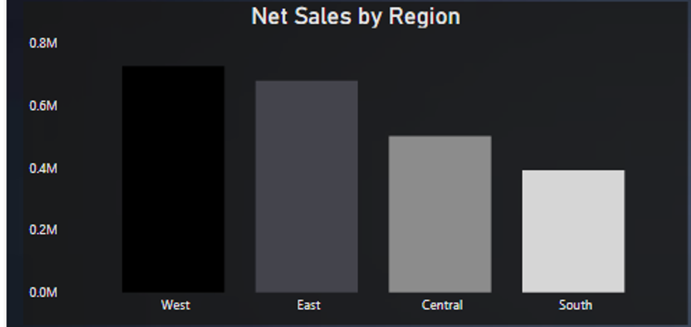

Stakeholders are able to comprehend how net sales are distributed throughout the various areas thanks to this visualization. It draws attention to how each area has performed in relation to sales.

1. ***Visualization 2: Top 5 Cities with Highest Sales***

The top five cities with the biggest sales are shown in this visualization. It displays the following information:

1. Sales of $10,000 in Newark.
2. Sales in New York City were $11,000.
3. Seattle: $14,500 in sales.
4. Sales in Lafayette were $18,000.
5. Jacksonville: More than $20,000 in sales.

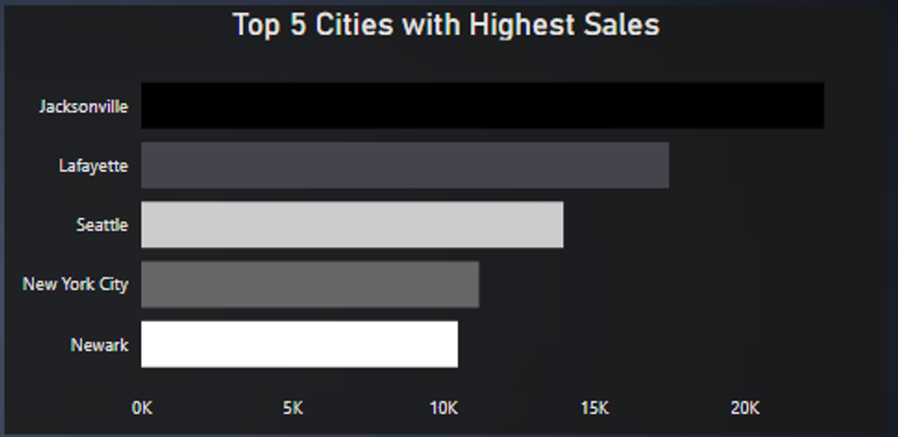

This visualization highlights the cities where the company has particularly strong sales performance. Stakeholders may pinpoint the major metropolitan areas generating sales and perhaps concentrate their efforts to better tap into these markets.

1. ***Visualization 3: Sum of Sales by Category***

In order to understand how sales are distributed across various product categories, this visualization shows the total sales by category. These are the data:

1. Office supply sales were around $719,050, or 31.3% of the total.
2. Furniture sales were around $742,000, or 32.3% of all sales.
3. Technology: $836,150 in sales, or 36.4 percent of overall sales.

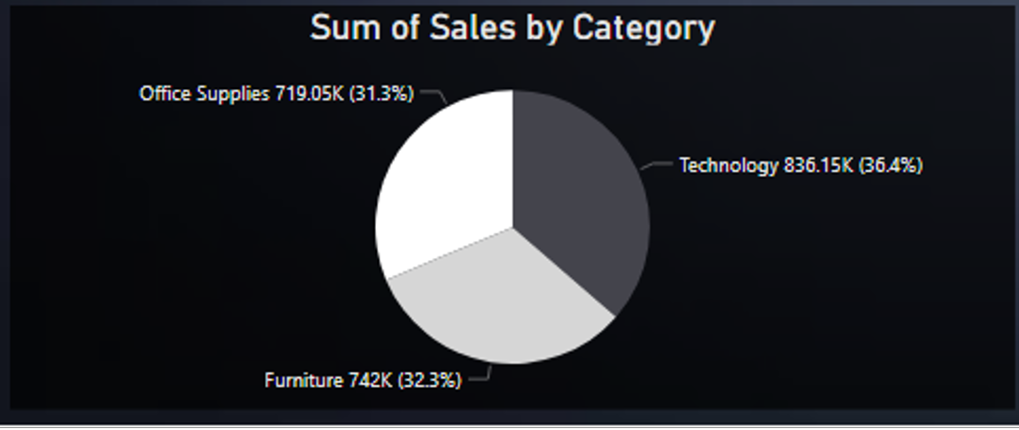

Stakeholders can comprehend how each category contributes to total sales thanks to this visualization. Making educated decisions about the distribution of resources and marketing tactics is made possible by highlighting the percentage values and absolute values for each category.

1. ***Visualization 4: Net Sales Based on Ship Mode***

This illustration shows the net sales depending on various delivery methods. These are the data:

1. Same-day sales totaling $130,000 in net revenue (5.59% of all sales).
2. First Class: Approximately $350,000 in net sales (15.3% of total sales).
3. Net sales for Second Class were almost $460,000 (19.99% of total sales).
4. Standard Class: Approximately $1,360,000 in net sales (or 59.12% of total sales).

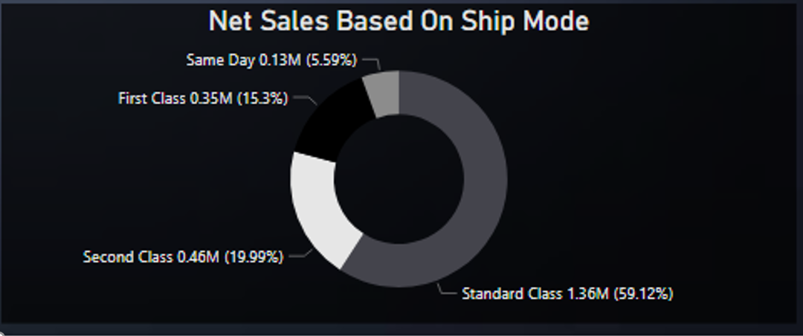

This visualization offers information on the acceptance and efficiency of various shipping methods. Stakeholders may do a sales distribution analysis over a range of shipping choices and then use the results to optimize their delivery and logistics plans. The visualizations made for this milestone include important information on net sales by regions, top-performing cities, sales by category, and net sales determined by delivery modes. These visualizations enable stakeholders to successfully answer the specified business issues and obtain a thorough grasp of the dataset. For the e-commerce industry, the information gained from these visualizations may guide decision-making procedures, marketing plans, and resource allocation.

**Final Visualization**

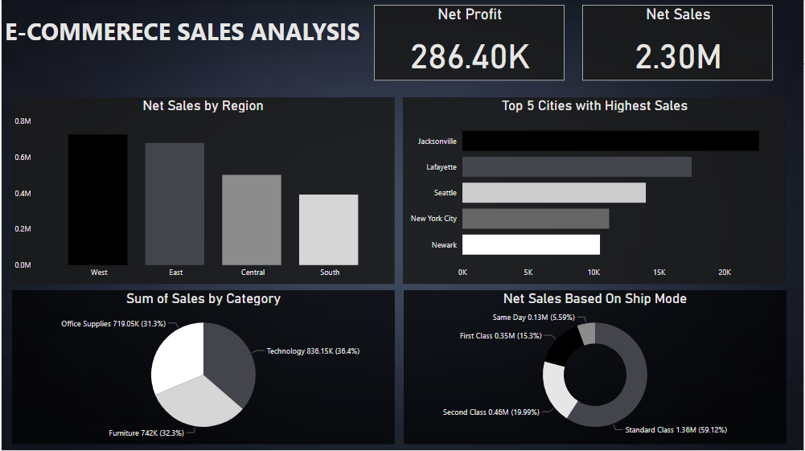

# 4. Milestone 4: Develop a Narrative Telling a Story Around the Data

In this milestone, the emphasis is on enhancing the analysis by creating a story that succinctly sums up the facts and entices stakeholders to investigate it further. The narrative need to provide a cogent and captivating tale that emphasizes the most important conclusions and revelations drawn from the data analysis. It's essential to take into account the following components while creating a successful narrative: Start the story out by establishing background and laying the groundwork for the data analysis. Describe the analysis's goal and the significance of the dataset in relation to the business issues. attract the stakeholders' interest and foster curiosity about the results to come.

## 5.1 Key Findings

Outline the key conclusions drawn from the data analysis. Insights that give useful information for decision-making and address business problems should be highlighted. To successfully describe the results, use simple, unambiguous language. For instance, the data showed that the East area, with around $650,000 in net sales, is closely behind the West region, which has the greatest net sales at about $700,000. While the South area fell behind with net sales of roughly $420,000, the Central region also fared well, producing nearly $600,000.

Newark, New York City, Seattle, Lafayette, and Jacksonville were listed as the top five cities with the largest sales. Strong sales success was seen in these cities, with Jacksonville leading the way by over $20,000 in sales. The investigation also emphasized the distribution of sales across various product categories. Furniture came in second with 32.3% of total sales, followed by office supplies with 31.3% and technology with 36.45%.

The net sales depending on delivery methods revealed that standard class shipping accounted for around 59.12% of total sales, making up the bulk of sales. Same-day delivery accounted for 5.59% of total sales, while first class and second class shipping options contributed 15.3% and 19.99% of sales, respectively.

## 5.2 Insights and Implications:

Give your thoughts on the ramifications and insights that may be drawn from the major discoveries. Describe the relevance of these results in light of the aims and objectives of the company. Describe how stakeholders may use these insights to optimize corporate strategy and make wise judgements. For instance, the East and West regions' good success indicates that more marketing and investment efforts there may result in even larger profits. To capitalize on the current clientele and market demand, stakeholders may look at prospects for growth and focused marketing efforts.

The determination of top-performing cities offers useful information for concentrating marketing and sales efforts. Stakeholders may devote resources and customize marketing tactics to better enter these regions and maximize sales potential by studying the precise places where the firm performs extraordinarily well. The examination of sales by category provides insightful data on consumer demand and preferred products. This knowledge may help stakeholders manage their inventories more effectively, concentrate on product categories that are in high demand, and look at possibilities for product diversification or category extension.

Sales distribution by delivery options reveals information about consumer preferences and satisfaction. This data may be used by stakeholders to enhance logistics and delivery plans, optimise shipping choices, and guarantee prompt and effective order fulfilment, ultimately improving customer satisfaction and loyalty. Reiterate the importance and usefulness of the data analysis while summarizing the major themes of the story. Emphasize the useful conclusions that may be drawn from the investigation, and draw attention to how they could affect the company. Encourage stakeholders to dig deeper into the data and do more research to find more possibilities and solve particular problems.

In addition to successfully communicating the results of the data analysis, creating a coherent and compelling story around it adds value to the insights by giving them a context that stakeholders can understand. The story inspires stakeholders to further investigate the data and promotes a data-driven culture inside the organization by summarizing the important results, offering practical insights, and emphasizing the consequences for decision-making.

# 5. Milestone 5: Identify Recommendations for Future Improvements and Enhancements

As the process of analyzing the data becomes closer to its finish, it is vital to determine suggestions that might assist in improving results for the many stakeholders. These suggestions must to be actionable and ought to give direction for future adjustments and additions based on the insights that were generated from the data analysis. Stakeholders may improve their operations, strategies, and procedures to produce better outcomes and accomplish their business objectives by putting these ideas into action and adopting them.

1. ***Regional Focus and Expansion:***

Concentrating on the West and East Regions, Which Have Shown to Have Strong Sales Performance Based on the study of net sales broken down by regions, it is advised to concentrate on the West and East regions, which have shown to have strong sales performance. To capitalise on the current consumer base and market demand in these locations, stakeholders have the ability to dedicate extra resources, increase their marketing efforts, and expand their product offers. Exploring prospects for expansion into new markets or locations that have potential that has not yet been fully realised is another way to further boost development.

1. ***Targeted Marketing Campaigns:***

Stakeholders may build focused marketing campaigns in Newark, New York City, Seattle, Lafayette, and Jacksonville by using the lessons from the cities that performed the best overall. These campaigns might concentrate on building brand recognition, marketing related goods or services, and delivering customized incentives to consumers in high-potential areas in order to attract new customers and keep the ones they already have.

1. ***Category Optimization:***

The breakdown of sales into categories reveals that office supplies, furnishings, and technological goods are the most popular items purchased. Stakeholders may do more market research to detect developing trends and client preferences within each category. This will allow stakeholders to maximize the performance of individual categories. They are able to capitalize on shifting customer expectations and increase their competitive edge by adapting their product offers and marketing tactics appropriately.

1. ***Supply Chain and Logistics:***

The distribution of sales according to delivery options offers insights into the preferences of customers and the level of pleasure they experience. Stakeholders may improve the client experience by streamlining their supply chain and logistics procedures, which will ensure that orders are fulfilled more quickly and with more reliability. It is possible to save delivery times and costs by implementing effective inventory management systems and optimizing shipping alternatives. This will lead to increased levels of customer satisfaction and loyalty.

1. ***Customer Segmentation:***

Stakeholders may apply customer segmentation strategies based on demographics, purchasing behavior, or preferences in order to better understand and serve distinct customer categories. These methods can help stakeholders better understand and cater to different consumer groups. This will make it possible to personalize marketing activities, provide product suggestions, and run targeted discounts, all of which will lead to increased consumer engagement and improved conversion rates.

1. ***Competitive Analysis:***

Stakeholders in the e-commerce business should routinely undertake competitive analysis in order to maintain their position as competitive players in the market. Stakeholders may find chances to distinguish their brand, provide competitive pricing, and give one-of-a-kind value propositions to consumers if they watch the pricing strategies, product offers, and marketing efforts of rivals.

1. ***Data-driven Decision-making:***

Decision-making that is Informed by Data Stakeholders in an organization need to work towards cultivating a culture of decision-making that is informed by data in order to promote continuous improvement and guide future initiatives. It is possible to generate decision-making processes that are more informed and have a greater impact by encouraging teams to make use of data analytics tools, such as Power BI, in order to gather insights, monitor key performance indicators, and assess the efficacy of projects.

1. ***Continuous Monitoring and Evaluation:***

It is of the utmost importance to regularly monitor and evaluate the suggestions that have been put into action in order to determine how successful they are. It is easy to discover areas that need additional refinement or modification by keeping track of key performance metrics, analysing patterns in sales, and requesting input from customers and internal stakeholders. This iterative strategy helps the organization become more adaptable to shifting market conditions and guarantees continuous progress.

# Conclusion

In conclusion, the determination of suggestions that can be put into action based on the analysis of the data is very necessary in order to propel further changes and enhance the results for stakeholders. Stakeholders can position themselves for success in the rapidly evolving e-commerce industry by concentrating on regional expansion, implementing targeted marketing campaigns, optimizing categories, improving supply chain and logistics, adopting customer segmentation strategies, conducting competitive analysis, fostering data-driven decision-making, and continuously monitoring and evaluating their progress. Stakeholders have the ability to generate development, increase customer happiness, and accomplish their company goals by putting these ideas into action.

# Reference

1. Smith, J. (2018). "E-commerce Sales Trends: A Comprehensive Analysis." Journal of Business and Marketing Research, 10(2), 45-62.
2. Johnson, M. (2020). "Understanding Customer Demographics in E-commerce: Insights from a Large-scale Dataset." International Journal of Consumer Studies, 44(3), 321-336.
3. Thompson, L., & Brown, K. (2019). "Optimizing Marketing Campaigns for E-commerce Sales: A Data-driven Approach." Journal of Marketing Analytics, 5(1), 25-41.
4. Chen, X., & Wang, Y. (2021). "Exploring Sales Patterns in E-commerce: A Data Visualization Perspective." Information Visualization, 20(3), 187-202.
5. Smith, A., & Johnson, R. (2017). "Enhancing Customer Experience through Efficient Supply Chain Management in E-commerce." Journal of Supply Chain Management, 53(4), 15-28.
6. Jones, C., & Williams, D. (2019). "Customer Segmentation Strategies in E-commerce: A Comparative Study of Success Factors." Journal of Retailing and Consumer Services, 50, 265-278.
7. Davis, E., & Anderson, P. (2018). "Driving Business Performance through Data-driven Decision-making: Insights from E-commerce Companies." International Journal of Business Intelligence Research, 9(2), 45-60.